ASSIGNMENTS ON DIGITAL MARKETING

NAME : BARATH KUMAR S
DEPARTMENT : B.E.BIOMEDICAL ENGINEERING
COLLEGE: 8151 DHANALAKSHMI SRINIVASAN INSTITUTE OF
TECHNOLOGY
NAANMUDHALVAN COURSE : DIGITAL MARKETING
NM TEAM ID : NM2023TMID02352
NM ID : F375D9839EF8ADF80614BD810010B174

ASSIGNMENT 1:
Create a blog or website using Blogspot and WordPress. Customize
The theme design and post new article with 500 words.
Website: https://soulcreators12.wordpress.com/

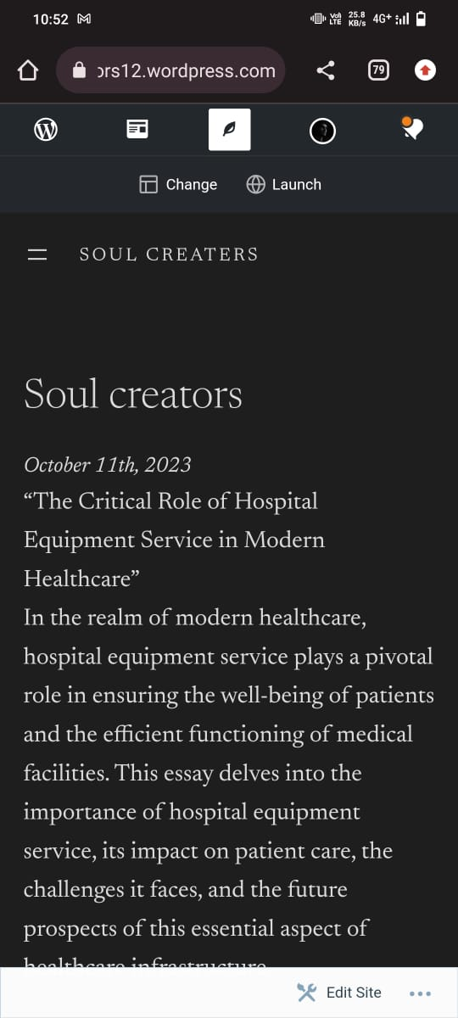

ASSIGNMENT 2:
Create a new Facebook business Page and Post one social media poster for your brand.
Website : https://www.facebook.com/soul.creators.2023?mibextid=ZbWKwL

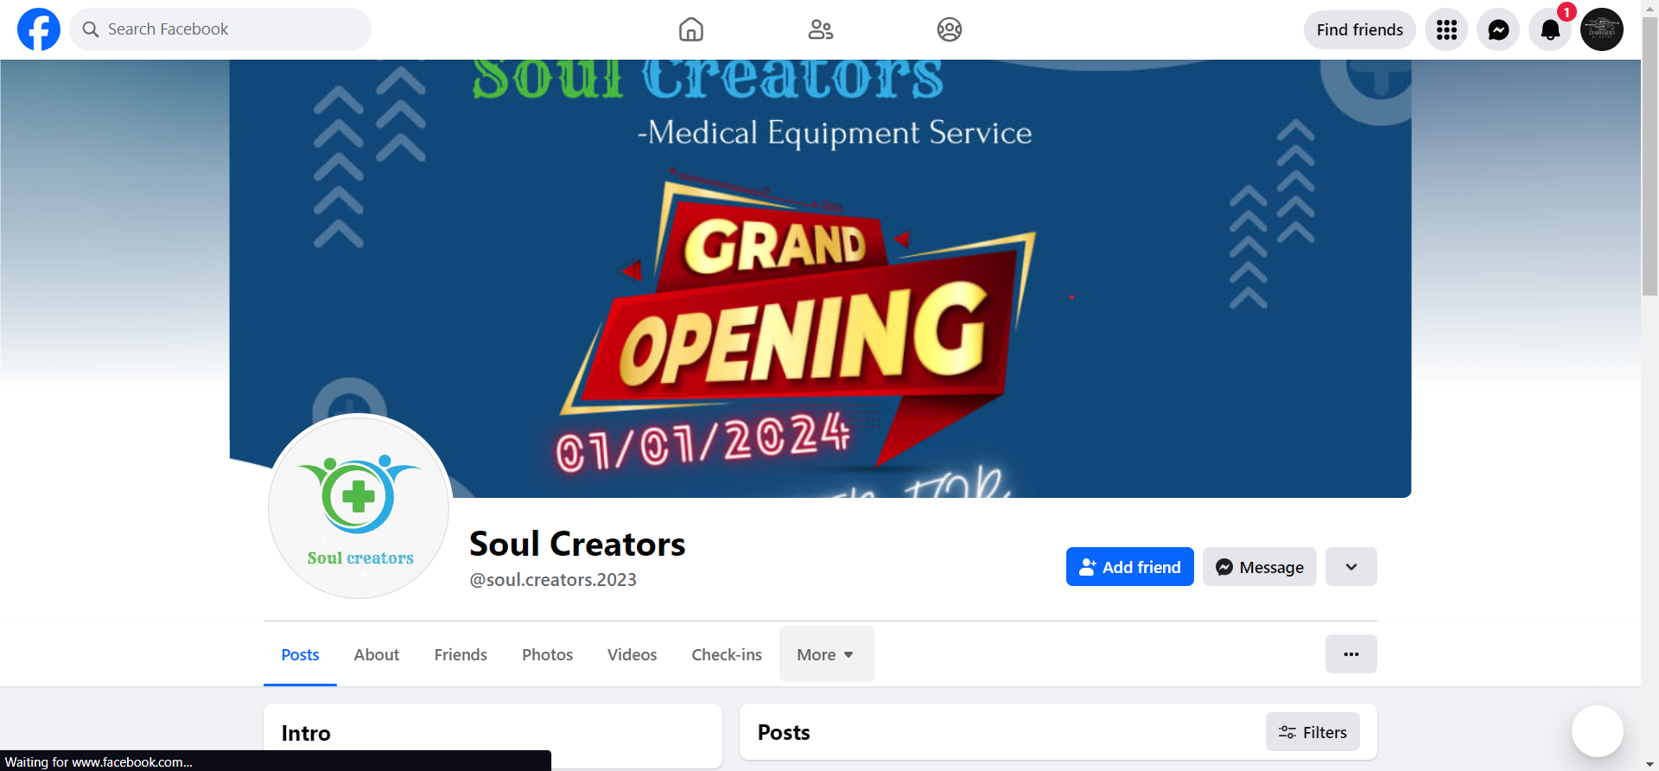

ASSIGNMENT 3:
Create and design a social media advertisement poster using Canva
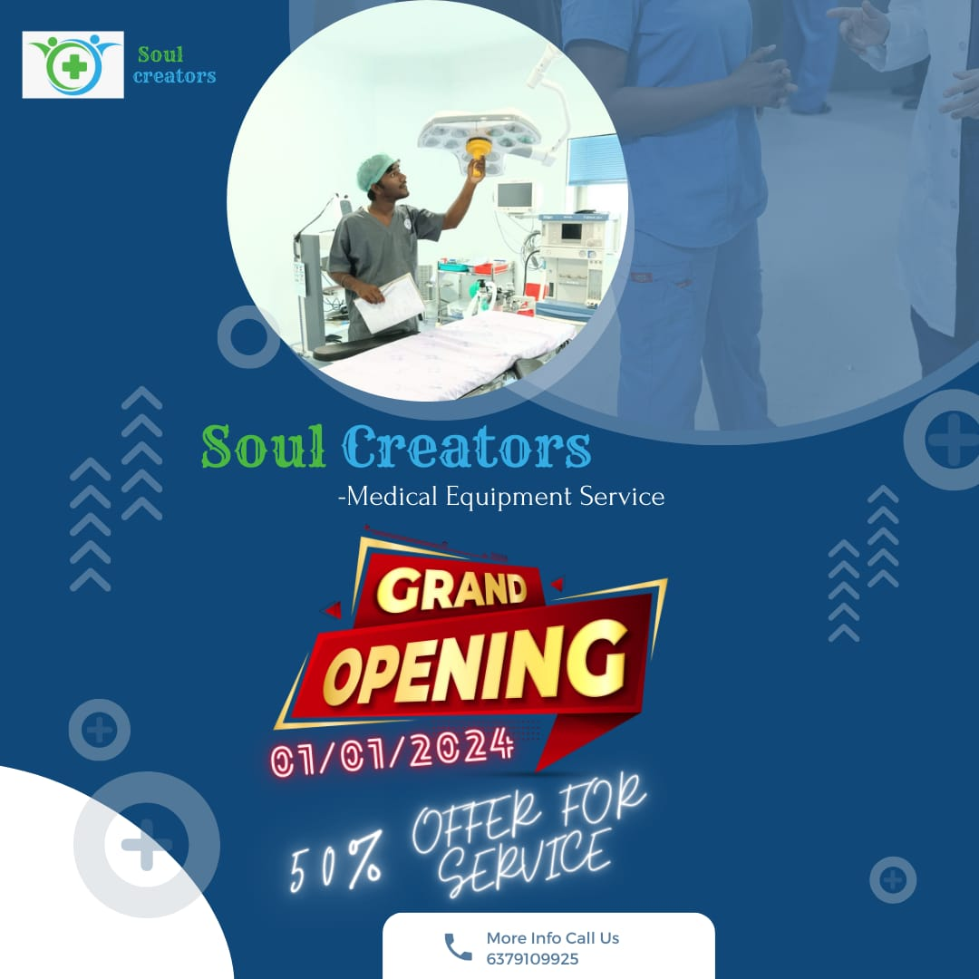
ASSIGNMENT 4:
4.Create email newsletter design using MailChimp or Canva tool.

